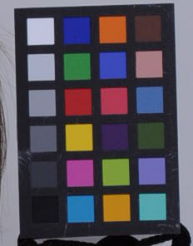

19

24

6

1

1. Cut patches from original (uncalibrated) image in Faststone save as 1.tiff, 2.tiff etc to 24.tiff (ensure no black border is sampled– so take a relatively small patch from centre to be sure to avoid any blurring between black border and colour patch.)

2. Compute average RGB values of each of these patches using the most recent ‘averageColourd65.m’ script **(very important to use most recent script as this is where the problems were).**

Edit script “makeRave.m”, the top set of figures is the *observed* values of the original patches that you just measured (in RGB space), the bottom set is the *target* values in L*a*b*, under d65* as measured by the spectro.

The target values from the most recent measurements of our chart are in “Mini_chart_target_values_d65_2011.txt”. (Organised #1-24, columns = l,a,b)

*(N.B. Amanda These values can be either manufacturer specified values of your chart, or ideally) spectrophotometer measurements of your actual chart in d50 if you are using this illuminant still.

Copy the chart’s target L*a*b* values from this text file into the bottom array in makeRave.m (within the [] brackets).

spectrod65= []

With the observed and target values inserted, save makeRave.m

Then run makeRave.m in Matlab using the following command

makeRave

Then you are ready to calibrate any image (*.tif) that you want (according to the colour transformation between ‘observed’ and target values) by typing the following command

RGB2sRGB_Image(‘imagename.tif’,R,’lab’)